Update ISO

# Overview

Update ISO fetches ISO Details saved as a configuration element and add new ISOs to it.

# Goal

It is prepared to achieve automated addition of new ISOs to the existing list which earlier was being done manually.

# Solution/Logic Design

ResourceConfiISOFile(Configuration Element)

Fetch ISO Details

If inputted ISO name exists in ISO names array

If yes

end

Update the ISO Details with the new ISO entry(ISO name, description,Path value)

Update the array of ISO names as well with the new ISO name

end

# Properties

* ISO name – Name of the ISO
* ISO Path – Path of the ISO
* ISO Description – description of the ISO

Dependencies

# Related Actions

Not Applicable

# Related Workflows

Not Applicable

# Related Configuration Elements

* ResourceConfISOFile – Configuration element which contains ISO Details from which data needs to be modified, updated or deleted.

# Attributes

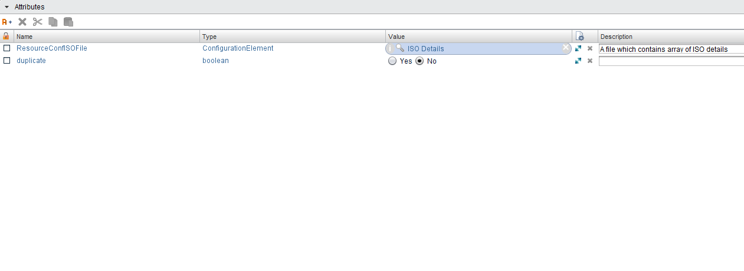

# Inputs

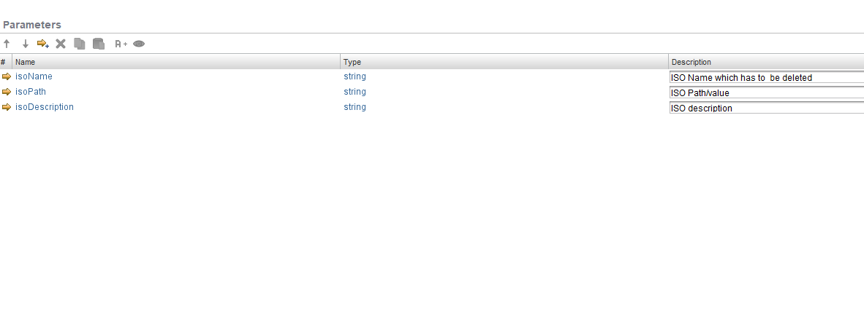

# Future Scope

It can be extended to:

* ISO details can be in different modes like a CSV file, Text file etc. .